UML PJBL Website BKK SMKN 1 PKC

1. Use Case

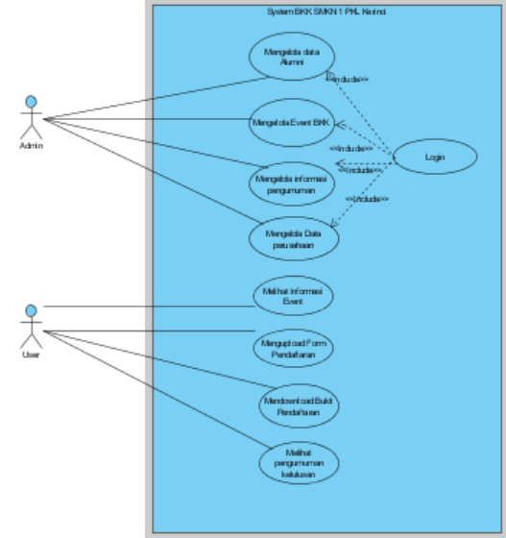

1. Activity Diagram
   1. Activity diagram User -pendaftaran event

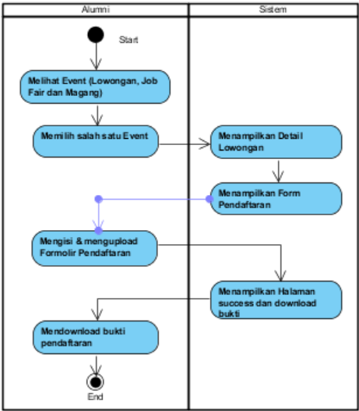

* 1. Activity diagram Admin - Mengelola Event

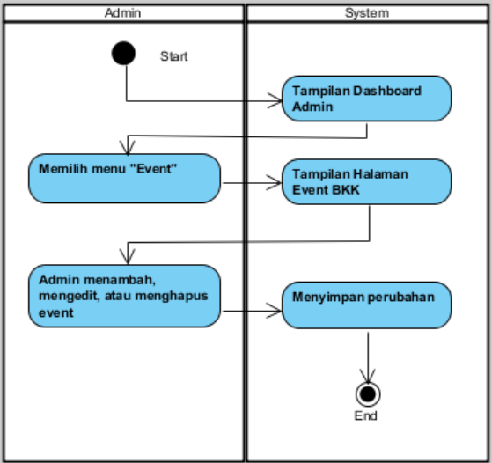

* 1. Activity diagram Admin - Login Admin

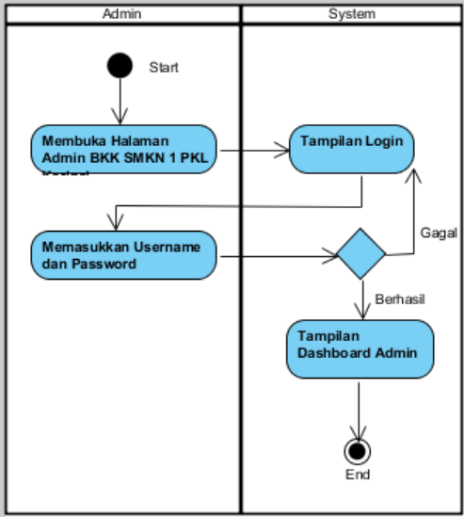

* 1. Activity diagram Admin - Mengelola Data Alumni

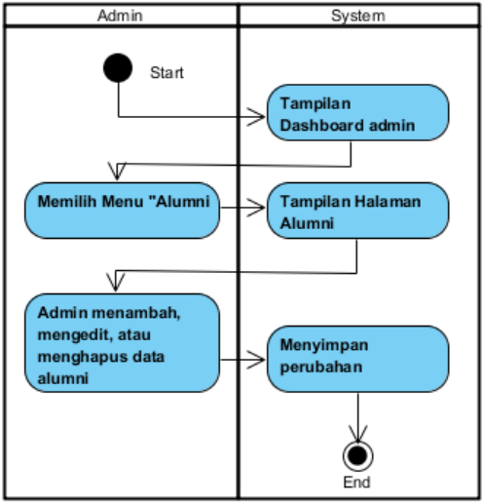

* 1. Activity diagram Admin - Mengelola Informasi Pengumuman

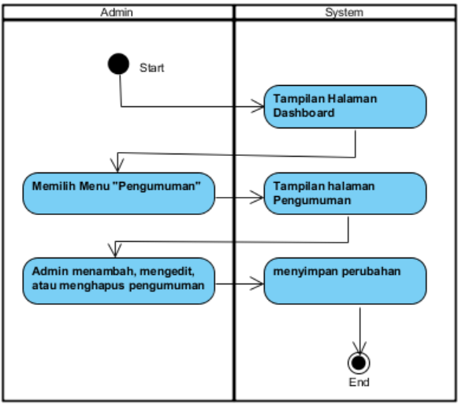

* 1. Activity diagram Admin - Mengelola Data Perusahaan

